Environment Setup and Execution Pathology application

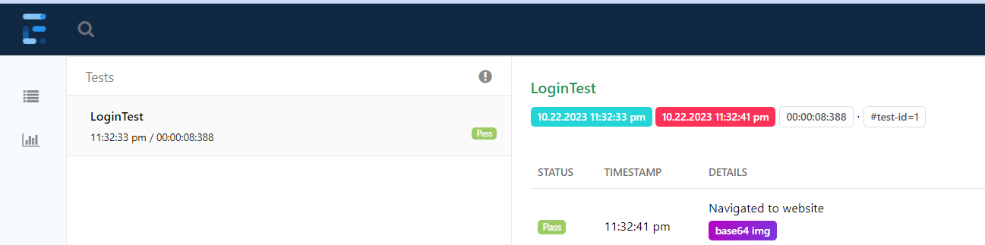

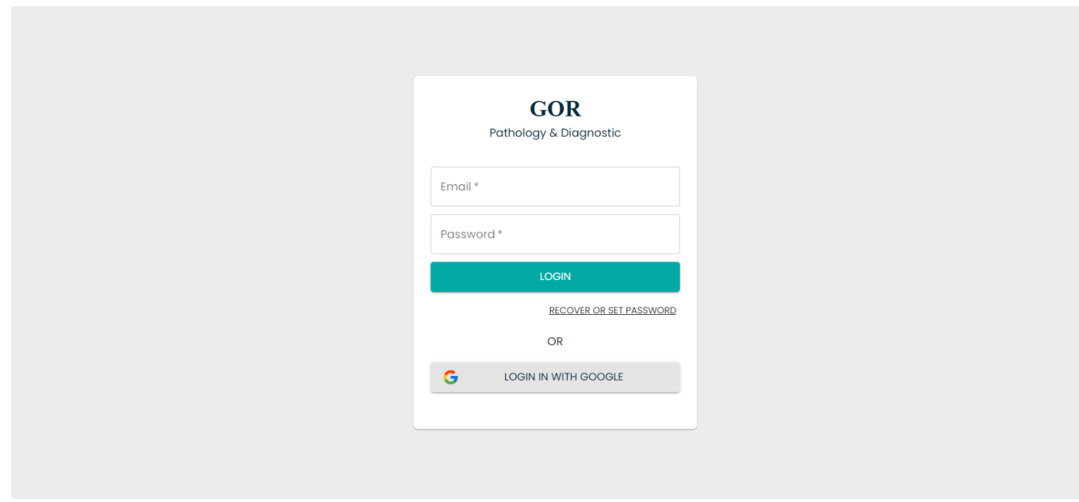

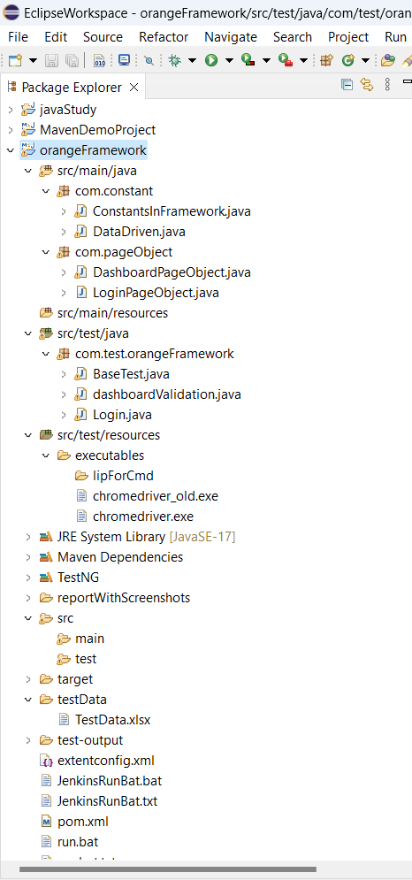

In this Assessment, I have created simple frame work (OrangeFrameWork) in Selenium with TestNG and java binding.

* I have used Page object model as design pattern
* 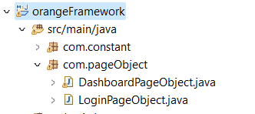

Where in I have created java class for each page such as login page and dashboard page.

* I have created com.constant package in which all the constant methods are being placed for reusability purpose.

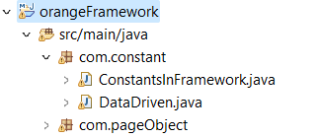

Eg:

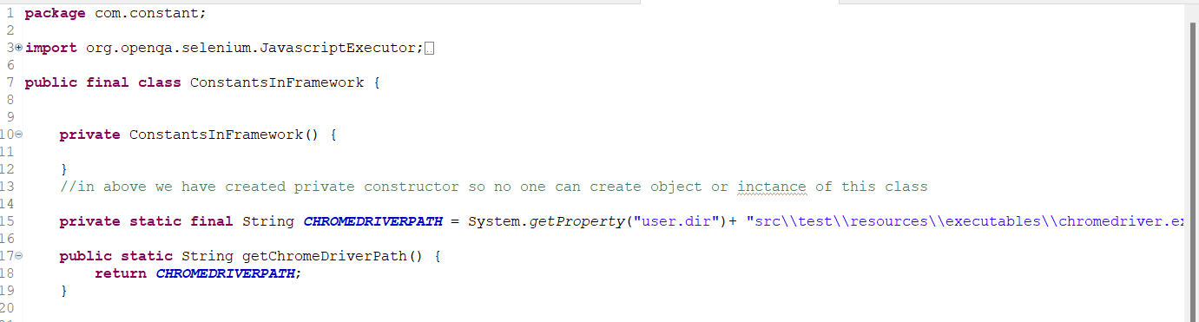

Driver path

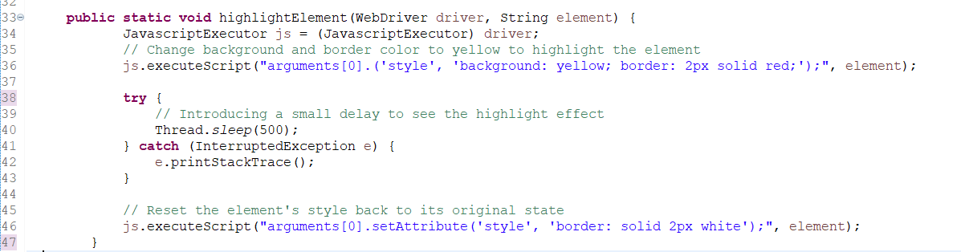

Highlight Elements methods etc.

* In the same constant, I have used data driven approach for fetching test data from Excel sheet.

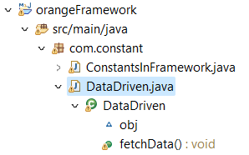

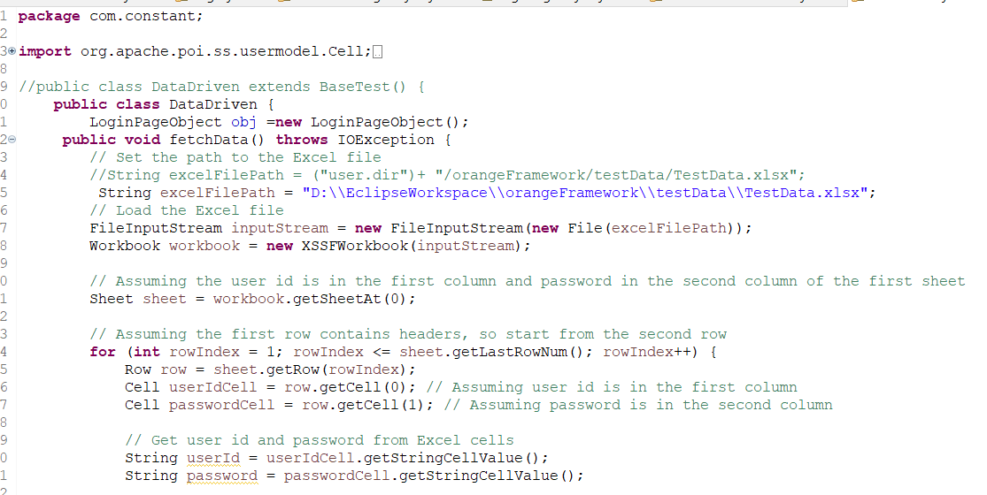

Here I have created method to fetch data such as user name and password from excel sheet so that there will not be any hardcoded data in testcase.



Going forward we have BaseTest where we have all methods that are necessary for all the testcases such as launching and initialization of web browser and driver.

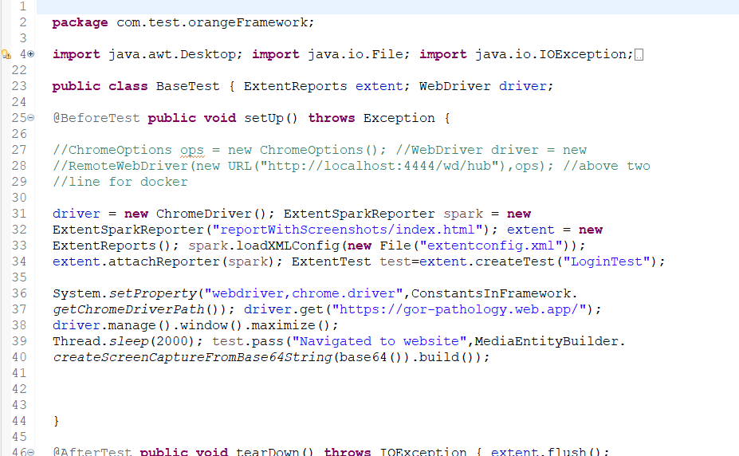

Example @Before and @After Class.

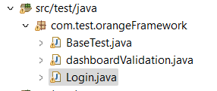

In test we have main java file of testcase where @Test is Exisit

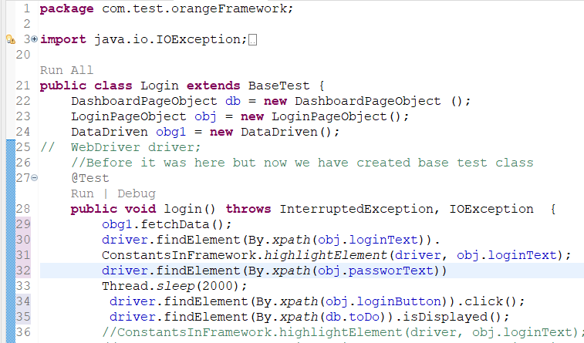

Here I created testcase to login into pathology application and Validate dashboard functionality

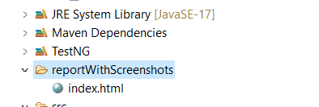

I have also integrated this framework with Extent Report where we have screenshot of execution flow along with validations.

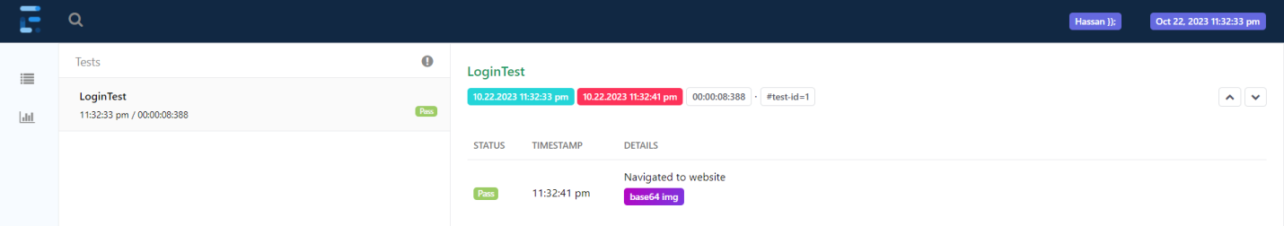

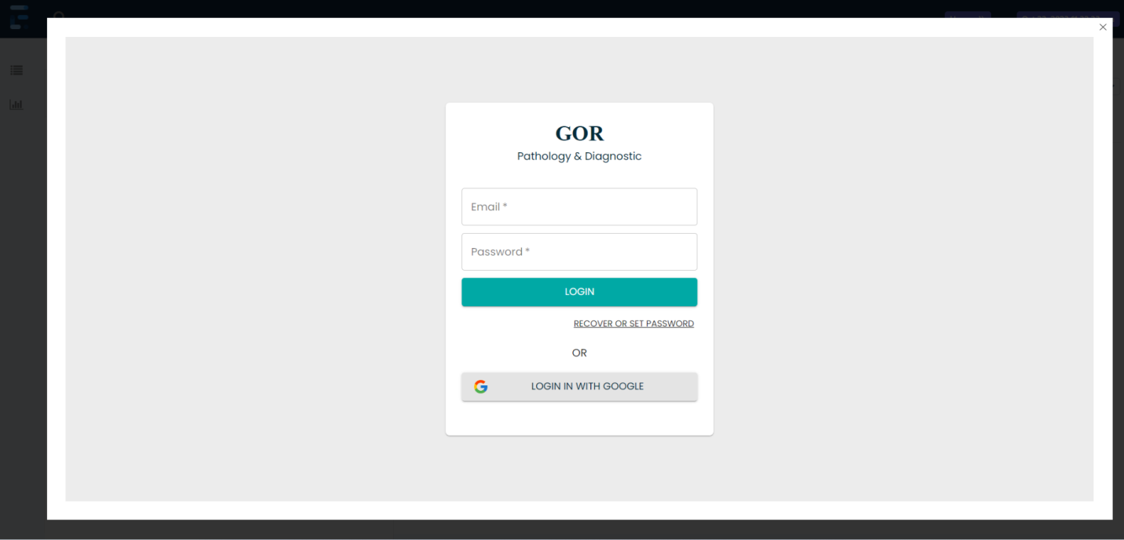

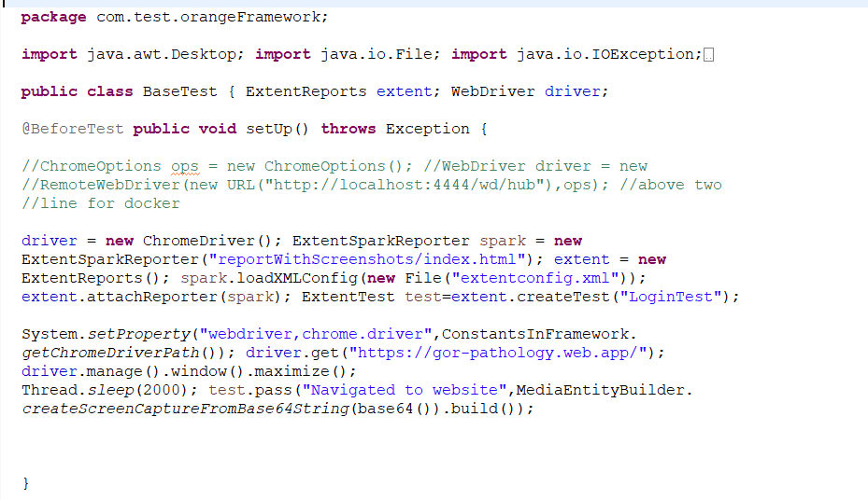 

Above is the code used for extent report

All the maven dependency that are being used in this project are mentioned below.

